Code Smells Identified
Package java/org/jabref/gui/

1. java/org/jabref/gui/preview/CopyCitationAction.java: line 94-174
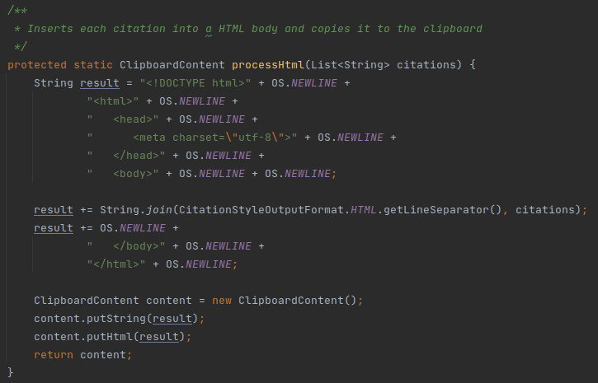
Problem: This class is doing more than it should. There should be an uniform way of formating citations to the various formats.

Refactoring Proposal: Extract the citation process methods on this class and place it in a suiting class the citationstyle package.
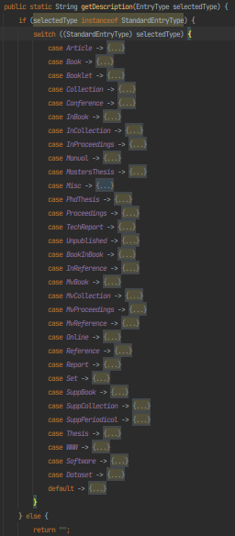
2. java/org/jabref/gui/EntryTypeView.java: line 210-316

Problem: This switch statement iterates through all the values in the Enum. If we wanted to add a new type of entry, or remove one, we would need to refractor 2 classes.

Refractoring Proposal: Extract this method and add description as an instance variable in the StandardEntryType Enum.
3. java/org/jabref/gui/fieldeditors/LinkedFileViewModel.java: lines 208, 226, 260, 312
Problem: The String “File not found” and “Could not find file ‘%0’.” can be found repeated throughout this class. This increases chances of creating inconsistencies.

Refractoring Proposal: Creating class constants for these Strings.

